**Input:**

using System;

using System.Collections.Generic;

using System.Linq;

using System.Text;

using System.Threading.Tasks;

namespace FirstApplication

{

internal class Program //ctor double tab

{

static void Main(string[] args)

{

Solution solution = new Solution();

//solution.PrintOrderNumber();

//solution.OddOrEven();

//solution.GreaterNumberForTwo();

//solution.GreaterNumberForThree();

//solution.PrintInBetweenNumbers();

//solution.IsPrime();

//solution.PrintInBetweenPrimeNumbers();

//solution.PrintNumbersDivisibleBySeven();

//solution.SumOfAllDigits();

//solution.IsPalindrome();

Console.ReadKey();

}

}

}

using System;

using System.Collections.Generic;

using System.Linq;

using System.Text;

using System.Threading.Tasks;

namespace FirstApplication

{

class Solution

{

int number1, number2, number3;

int tempnum1, tempnum2, tempnum3;

void TakeNumbers(int numAmount)

{

if (numAmount > 0 && numAmount <=3)

{

Console.WriteLine("Please enter the first number");

while (!int.TryParse(Console.ReadLine(), out tempnum1) || tempnum1 < 0)

Console.WriteLine("Please enter a positve number (integer)");

number1 = tempnum1;

if (numAmount > 1)

{

Console.WriteLine("Please enter the second number");

while (!int.TryParse(Console.ReadLine(), out tempnum2) || tempnum2 < 0)

Console.WriteLine("Please enter a positve number (integer)");

number2 = tempnum2;

if (numAmount > 2)

{

Console.WriteLine("Please enter third number");

while (!int.TryParse(Console.ReadLine(), out tempnum3) || tempnum3 < 0)

Console.WriteLine("Please enter a positve number (integer)");

number3 = tempnum3;

}

}

}

else

Console.WriteLine("Please choose only upto 3 numbers");

}

//1) Write a program that will take an input from user as number and print all the numbers

//from 0 to the given number.

public void PrintOrderNumber()

{

TakeNumbers(1);

for (int i = 0; i <= number1; i++)

{

Console.WriteLine(i);

}

}

//2) Create a program that will find out if the given number is odd or even

public void OddOrEven()

{

TakeNumbers(1);

if (number1%2 == 0)

Console.WriteLine("The number: " + number1 + " is Even");

else

Console.WriteLine("The number: " + number1 + " is Odd");

}

//3) Create a program that will take 2 numbers and find out the greates of the 2

public void GreaterNumberForTwo()

{

TakeNumbers(2);

if (number1 > number2)

Console.WriteLine("The number: " + number1 + " is greater than the number: " + number2);

else if (number1 == number2)

Console.WriteLine("Both number are equal");

else

Console.WriteLine("The number: " + number2 + " is greater than the number: " + number1);

}

//4) Improve the program written in question 3 to find the greatest of 3 numbers

public void GreaterNumberForThree()

{

TakeNumbers(3);

if (number1 > number2)

{

if (number1 > number3)

Console.Write("The first number: " + number1 + " is the greatest among the three numbers");

else

Console.Write("The third number: " + number3 + " is the greatest among the three numbers");

}

else if (number2 > number3)

Console.Write("The second number: " + number2 + " is the greatest among the three numbers");

else

Console.Write("The third number: " + number3 + " is the greatest among the three numbers");

}

//5) Take the minimum and maximum number from user and find all numbers inbetween

public void PrintInBetweenNumbers()

{

TakeNumbers(2);

if (number1 > number2)

{

Console.WriteLine("------");

for (int i = number2 + 1; i < number1; i++)

{

Console.WriteLine(i);

}

}

else

{

Console.WriteLine("------");

for (int i = number1 + 1; i < number2; i++)

{

Console.WriteLine(i);

}

}

}

//6) Find if a given number is prime

public void IsPrime()

{

TakeNumbers(1);

bool isPrime = true;

if (number1 < 0 || number1 == 0 || number1 == 1)

{

isPrime = false;

}

else

{

for (int i = 2; i <= number1 / 2; i++)

{

if (number1 % i == 0)

{

isPrime = false;

}

else

isPrime = true;

}

}

if (isPrime == true)

Console.WriteLine("The number: " + number1 + " is a prime number");

else

Console.WriteLine("The number: " + number1 + " is NOT a prime number");

}

//7) Improve the program in 5 to find all the prime numbers between the given numbers

public void PrintInBetweenPrimeNumbers()

{

TakeNumbers(2);

if (number1 > number2)

{

Console.WriteLine("------");

for (int inp2 = number2 + 1; inp2 < number1; inp2++)

{

bool isPrime = true;

if (inp2 < 0 || inp2 == 0 || inp2 == 1)

{

isPrime = false;

}

else

{

for (int i = 2; i <= inp2 / 2; i++)

{

if (inp2 % i == 0)

{

isPrime = false;

}

}

if (isPrime == true)

Console.WriteLine(inp2);

}

}

}

else

{

Console.WriteLine("------");

for (int inp1 = number1 + 1; inp1 < number2; inp1++)

{

bool isPrime = true;

if (inp1 < 0 || inp1 == 0 || inp1 == 1)

{

isPrime = false;

}

else

{

for (int i = 2; i <= inp1 / 2; i++)

{

if (inp1 % i == 0)

{

isPrime = false;

}

}

if (isPrime == true)

Console.WriteLine(inp1);

}

}

}

}

//8) Take input from user until the user enters a negative number and find the sum of all the numbers

//that are divisible by 7

public void PrintNumbersDivisibleBySeven()

{

int number1 = 0, sum = 0;

Console.WriteLine("Please enter the first number");

while (!int.TryParse(Console.ReadLine(), out tempnum1))

Console.WriteLine("Please enter a positve number (integer)");

number1 = tempnum1;

while (number1 >= 0)

{

if (number1 % 7 == 0)

sum = sum + number1;

Console.WriteLine("Please enter a number");

number1 = Convert.ToInt32(Console.ReadLine());

}

Console.WriteLine("The total number that is divisible by 7 is " + sum);

}

//9) Take a 4 digit number from user and find the sum of all the digits

//example - 1234 result should be 10

public void SumOfAllDigits()

{

Console.WriteLine("Please enter the number");

while (!int.TryParse(Console.ReadLine(), out tempnum1) || tempnum1 < 999 || tempnum1 > 9999)

Console.WriteLine("Please enter a 4 digit number (integer)");

number1 = tempnum1;

int sum = 0;

for (int n = number1; n > 0; sum += n % 10, n /= 10) ;

Console.WriteLine(sum);

}

//10) Take a 4 digit number from user and find if it is a palindrome or not

//example - 1234 result should be Not a plaindrome

//example - 1221 result should be Plaindrome

public void IsPalindrome()

{

Console.WriteLine("Please enter the number");

while (!int.TryParse(Console.ReadLine(), out tempnum1) || tempnum1 <999 || tempnum1 >9999)

Console.WriteLine("Please enter a 4 digit number (integer)");

number1 = tempnum1;

int tempValue = number1;

int reverse = 0;

while (tempValue > 0)

{

reverse = reverse * 10 + tempValue % 10;

tempValue = tempValue / 10;

}

if (reverse == number1)

Console.WriteLine("The number:" + number1 + "is a palindrome");

else

Console.WriteLine("The number:" + number1 + "is NOT a palindrome");

}

}

}

**Output:**

Question 1:

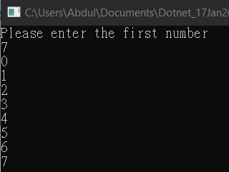

Question 2:

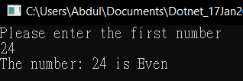

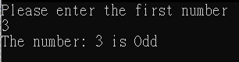

Question 3:

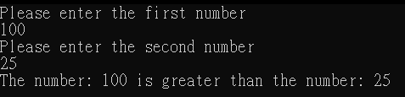

Question 4:

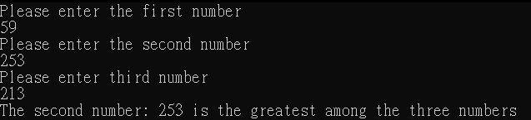

Question 5:

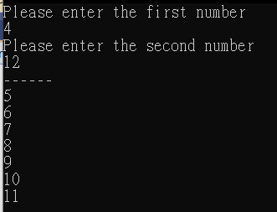

Question 6:

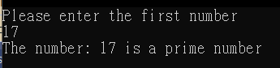

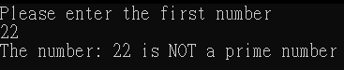

Question 7:

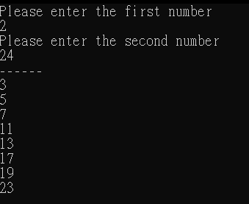

Question 8:

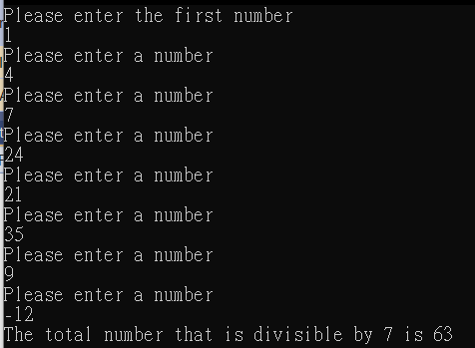

Question 9:

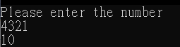

Question 10:

